Computer Networks Laboratory Week 7

Name : Tanishq Vyas
SRN : PES1201800125
Section : H
Semester : 5
Branch : CSE

TASK 1

Configurations :

HOST A :
IP Address = 10.10.1.1
Gateway = 10.10.1.2
DNS Server = 192.168.1.2

ROUTER 1 :
Incoming Interface IP = 10.10.1.2 (Fast ethernet 0)
OUtgoing Interface IP = 10.10.2.1 (Fast ethernet 1)

ROUTER 2 :
Incoming Interface IP = 10.10.2.2 (Fast ethernet 0)
OUtgoing Interface1 IP = 192.168.1.1 (Fast ethernet 1)
Outgoing Interface2 IP = 192.168.2.1 (External added interface)

DNS Server :
IP Address = 192.168.1.2
Default Gateway = 192.168.1.1

WEB Server :
IP Address = 192.168.2.2
Default Gateway = 192.168.2.1

Routing Table Entries :

Name | Network | Gateway
Router 2 | 10.10.1.0 | 10.10.2.1
Router 1 | 192.168.1.0 | 10.10.2.2
Router 1 | 192.168.2.0 | 10.10.2.2

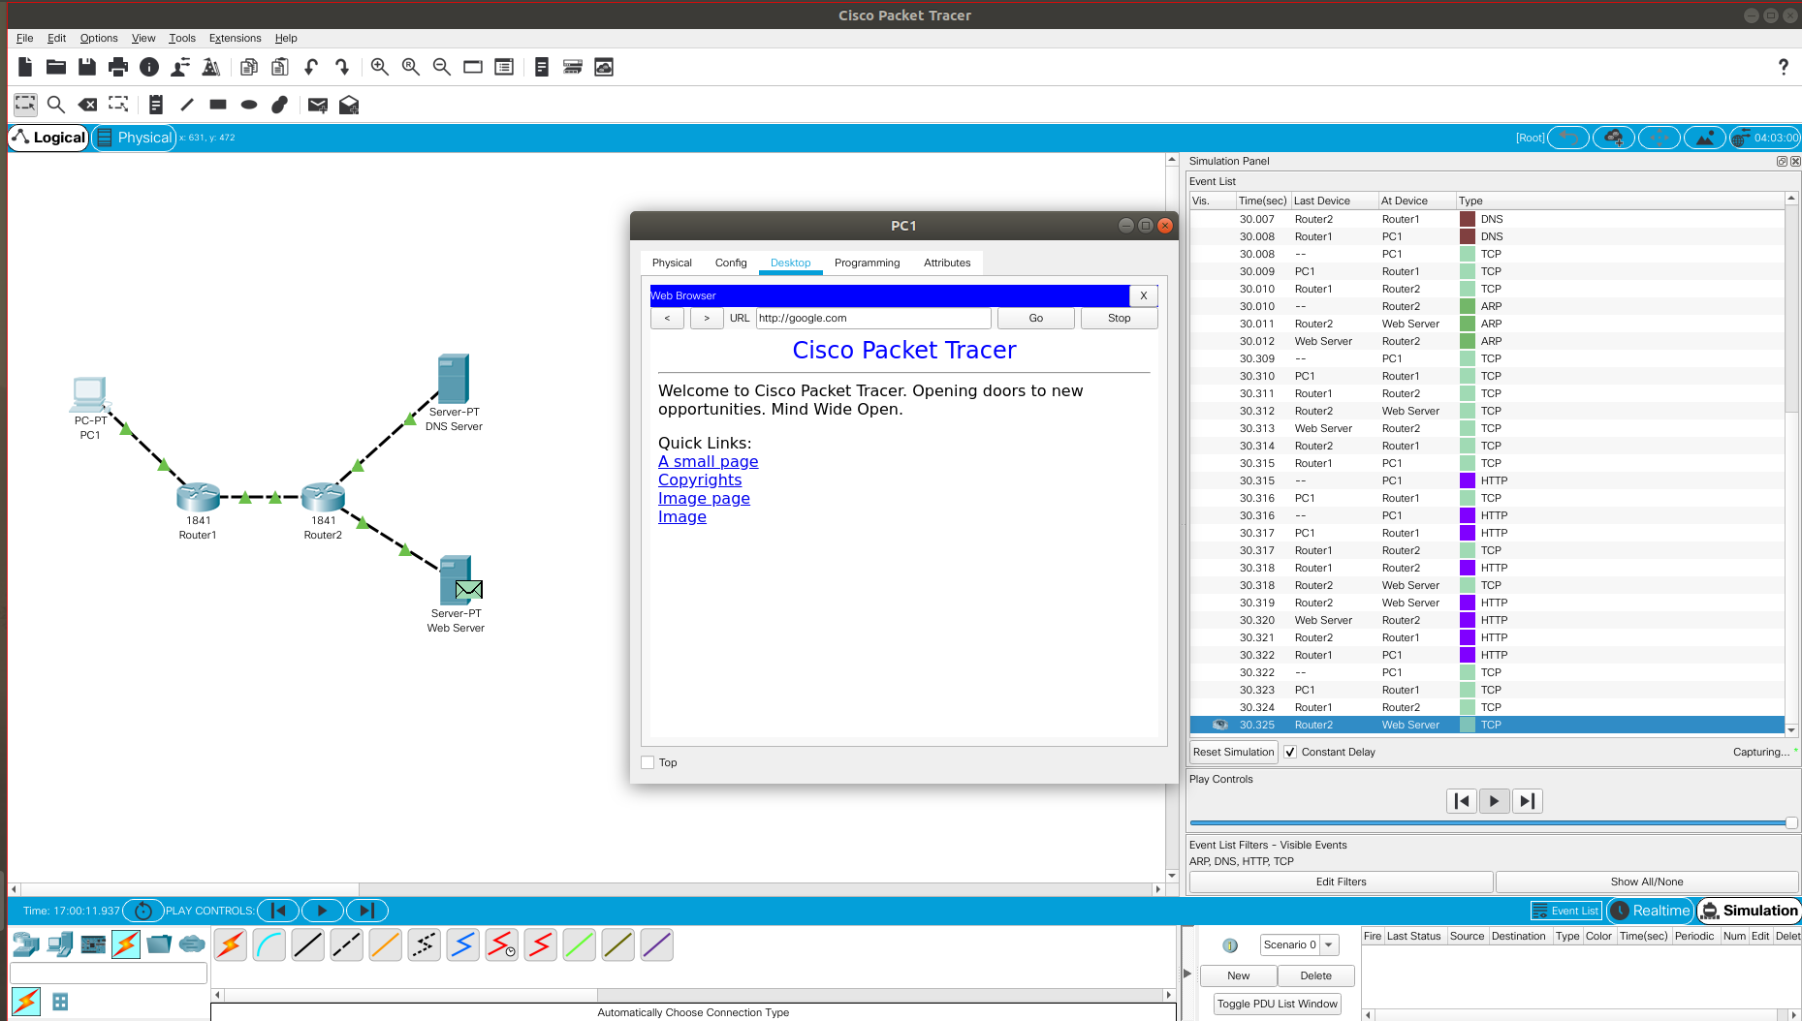

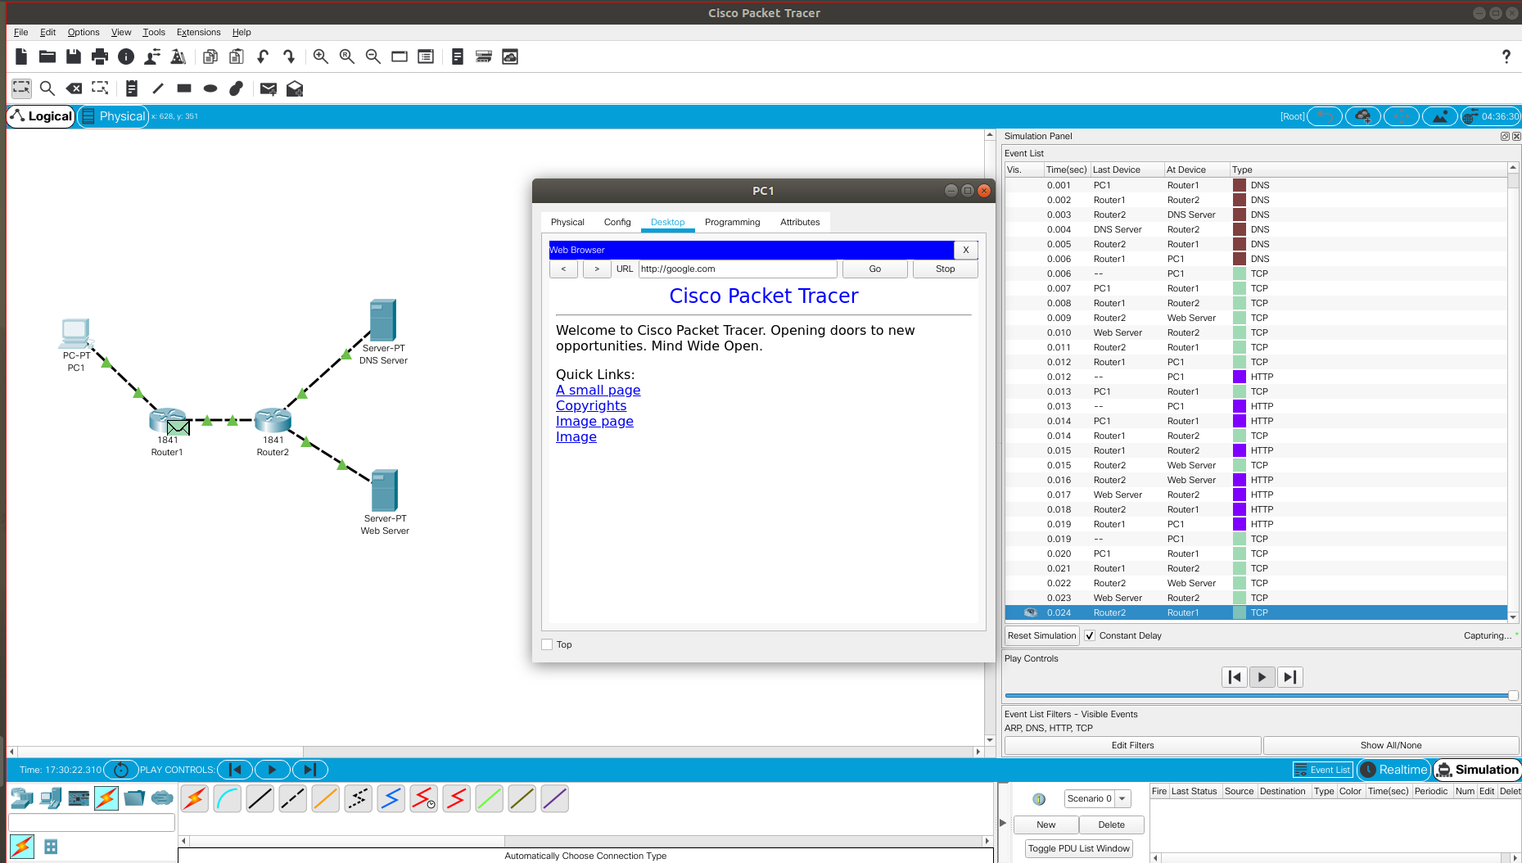

Fig : Packet Tracer Capture for Task 1

